Lab 4 plus
*Lab 4 plus is a combination of Lab 4 and an extra activity on ARP.

Packet Tracer Simulation – Exploration of ARP and Switch Table Communications

Objectives
- To explore ARP and switching operations.
Introduction
The topology is given to you. All IP addresses have been assigned to all devices. Please follow each step in sequence.
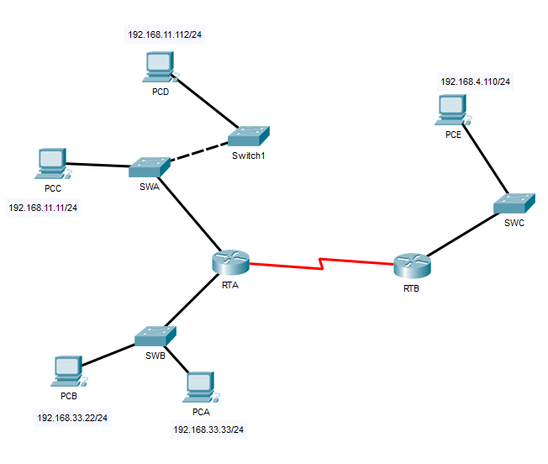
Figure 1

Part 1: Review the topology

Step 1: Perform the following tasks.
- At Router RTA, enter the CLI. At the command prompt type the following commands. Snap the results after the last command and paste it here.
RTA>enable

RTA#show arp

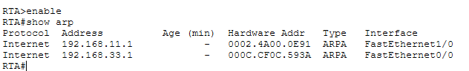
- At Router RTB, enter the CLI. At the command prompt type the commands as in Figure 2. Snap the results after the last command and paste it here.

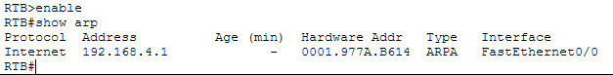

- At Switches SWA, SWAB and SWC, enter the CLI. At the command prompt type the following commands. Snap the results after the last command and paste it here.
SWA>enable

SWA#show arp

SWA#show mac-address-table

SWA:

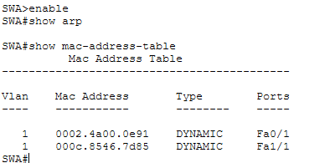

SWB:

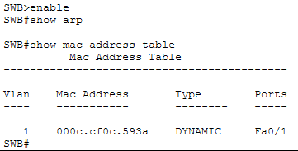

SWC:

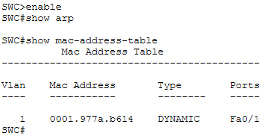
- At PCA, click on the PC icon, and then choose Desktop-Command Prompt. At the command prompt type arp –a and click enter. Snap the results after the last command and paste it here. Do this to all PCs in the topology.

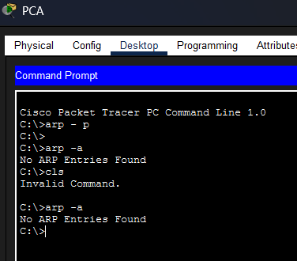

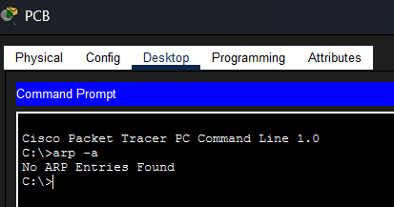

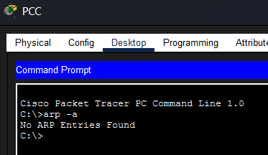

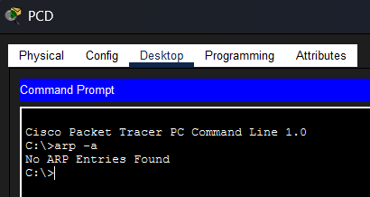

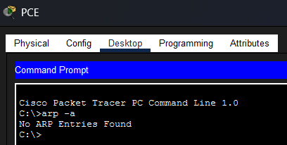

- What are your thoughts on the results?

There is no traffic generated yet. So the PC has not needed to resolve any MAC addresses.

Part 2: Generate Network Traffic

Step 1: Generate traffic between PCA and PCB.
In the command prompt Perform the following tasks task to reduce the amount of network traffic viewed in the simulation.
- Click PCA and click the Desktop tab > Command Prompt.
- Enter the ping 192.168.33.22 command. This may take a few seconds.
- In the Command prompt of PCA, type arp –a. Paste the result of this command here.
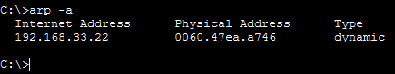
- In the Command prompt of PCB, type arp –a. Paste the result of this command here
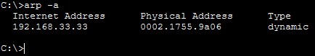

- In the Command prompt of PCC, PCD abd PCE, type arp –a. Paste the result of this command here.
  - PCC:
    - 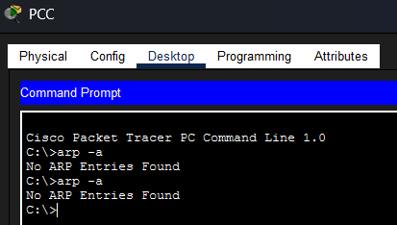
  - PCD:
    - 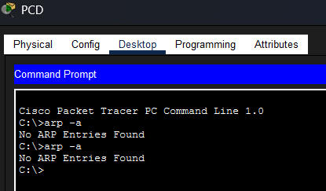
  - PCE:
    - 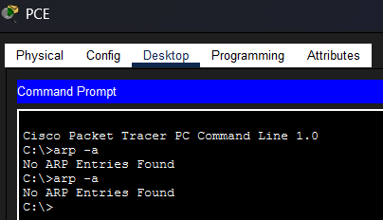

Step 2: Generate traffic between PCC to all other PC except PCA.
- Click PCC and click the Desktop tab > Command Prompt.
- Enter the ping 192.168.33.22 command (ping to PCB). Then type arp –a. Paste the result after these commands here.
  - 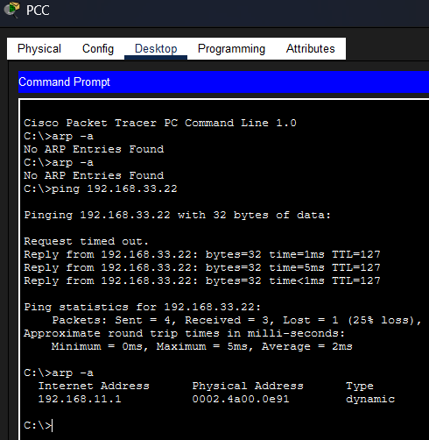

- Enter the ping 192.168.11.112 command (ping to PCD). Then type arp –a. Paste the result after these commands here.
  - 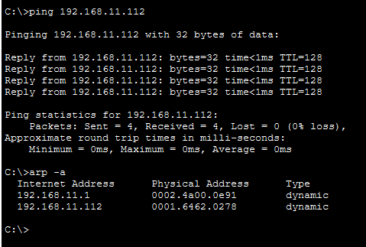
- Enter the ping 192.168.4.110 command (ping to PCE). Then type arp –a. Paste the result after these commands here.
  - 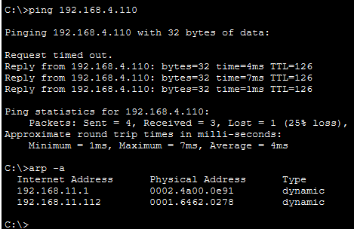

- Discuss the results you got from all the commands on PCC.
  - The results confirm successful connectivity, as all pings worked after a brief initial timeout caused by the normal ARP resolution process. The commands demonstrate correct routing behavior: PCC resolved the specific MAC address for the local device (192.168.11.112) but correctly used the Default Gateway's MAC address (192.168.11.1) to reach the remote networks (192.168.33.22 and 192.168.4.110).
- At Router RTA, enter the CLI. At the command prompt type the following commands. Snap the results after the last command and paste it here.
RTA>enable

RTA#show arp

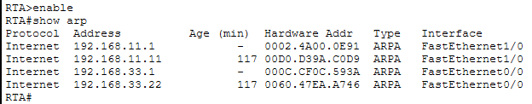
- At Router RTB, enter the CLI. At the command prompt type the following commands. Snap the results after the last command and paste it here.
RTB>enable

RTB#show arp
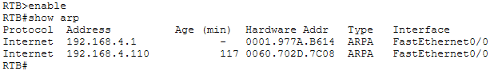

Step 3: Switch MAC address table.
- At Switch SWA, enter the CLI. At the command prompt type the following commands. Snap the results after the last command and paste it here.
SWA>enable

SWA#show arp

SWA#show mac-address-table

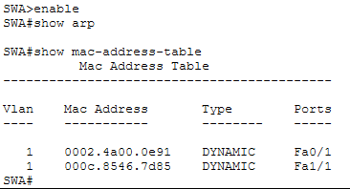
- At Switch SWB, enter the CLI. At the command prompt type the following commands. Snap the results after the last command and paste it here.
SWB>enable

SWB#show arp

SWB#show mac-address-table
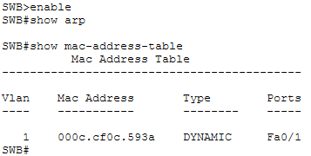

- At Switches SWC and Switch1, enter the CLI. At the command prompt type the following commands. Snap the results after the last command and paste it here.
SWC>enable

SWC#show arp

SWC#show mac-address-table
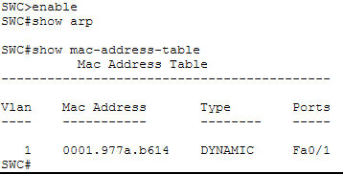
- Do switches use arp table? (Y/N)
  - Y
- Explain your answer in (d) *Hint: the answer may surprise you. Google for the explanation. It is not part of NetComm syllabi, it is just for knowledge..
  - If you assign an IP address to a switch (to Ping, Telnet, or SSH into it), the switch needs to reply to you. To send that reply, it must map your IP address to your MAC address, just like a PC does. Therefore, it maintains its own ARP Table strictly for its own management traffic, even though it doesn't need one to switch data between other devices.
- What information does the command show mac-address-table gives?
It lists the mapping between MAC addresses and switch ports, telling you exactly which physical port a specific device is plugged into and which VLAN it is on.

Part 3: Attach wireless lab results.
In this part, you will use Lab 4 .pka file.
Step1: Change the filename of Lab 4.
- Change the Lab 4 filename to include your name. *Example: Lab4AliAhmad.pkt
- Go through the instructions. As you complete the tasks, you will see the bottom right hand corner of the pkt file increase in completion percentage, until you get 100/100.

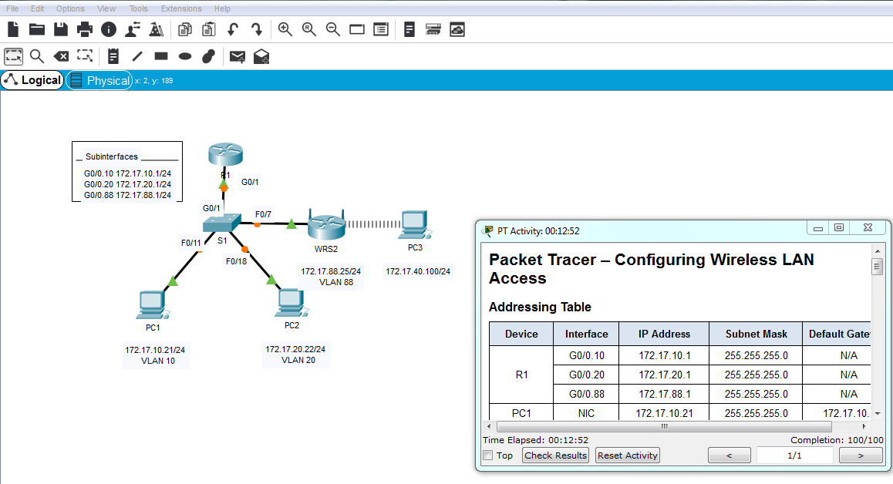
- Once you have completed fully, capture the screen (which includes the filename, the topology and the activity wizard showing completion) and paste it here.
